# Exercises: What to Mine?

In this exercise you will learn how to choose the **optimal cryptocurrency to mine**. There is many and many coins in the world of cryptocurrencies, but which of them is the best for your hardware. We will look for the answer of this question on web site [https://whattomine.com](https://whattomine.com/).

## Visit “Whattomine”

1. Go to website: [https://whattomine.com](https://whattomine.com/). In first section you can choose you hardware. Here is the most popular mining GPUs and ASICs.

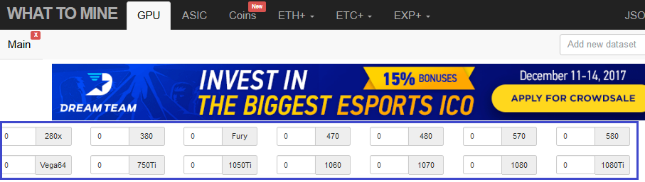

1. Let`s choose one **AMD Radeon RX 570** card.

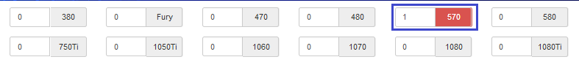

1. Downwards are hashing algorithms with “**Hash rate**”, “**Power**” consumption and “**Daily cost**”. Here you can see the **reference** values for your hardware. The site gives you the default values but you can enter your own parameters.

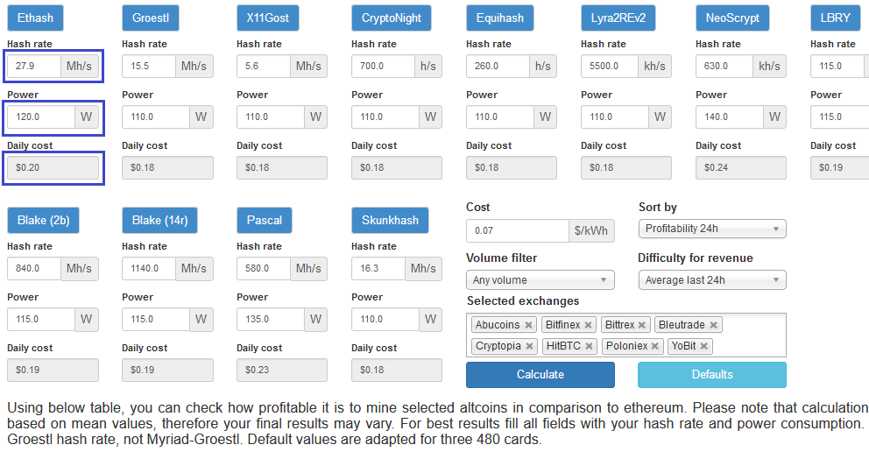

1. In the “**Cost**” field you can enter price that your pay for electricity.

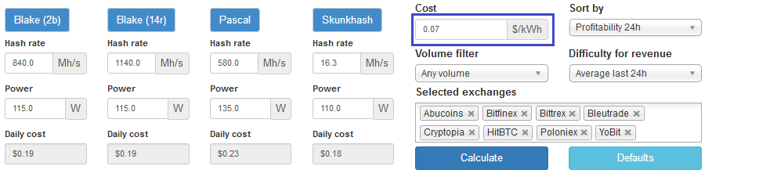

1. You can **change** the **sorting criteria** from drop-down list “**Sort by**”. This is important to choose the right options. For example, if you use profitability for last 24h, this will show the most **actual** currencies, but while you manage to mine the coins, the leadership can be already changed. The longest periods like last 3 or 7 days give you the more **stabile** picture of mining situation.

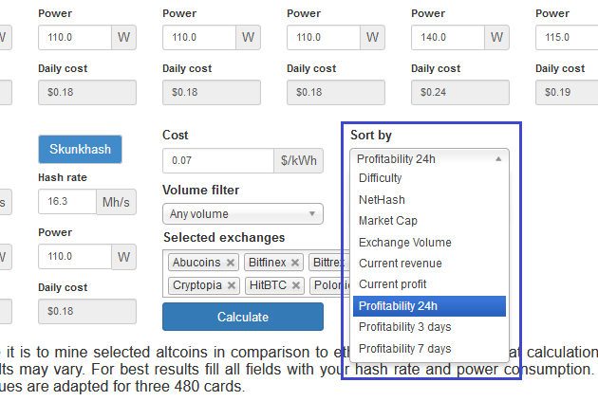

1. With same logic you can choose the **difficulty for revenue calculations**. The more longest period – the more stable picture.

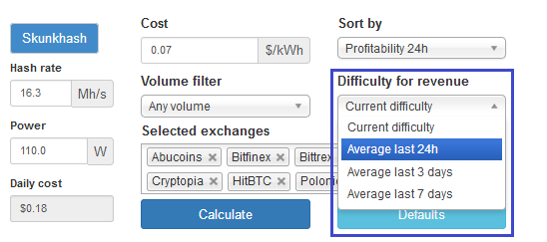

1. When you are ready click on “**Calculate**” button.

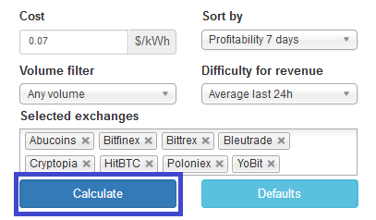

1. Scroll down and you will see the **crypto coins** ordered by your criteria. Remember that not always the leader is the best choice and very often the doubtful coins are very attractive but for a **very short time**.

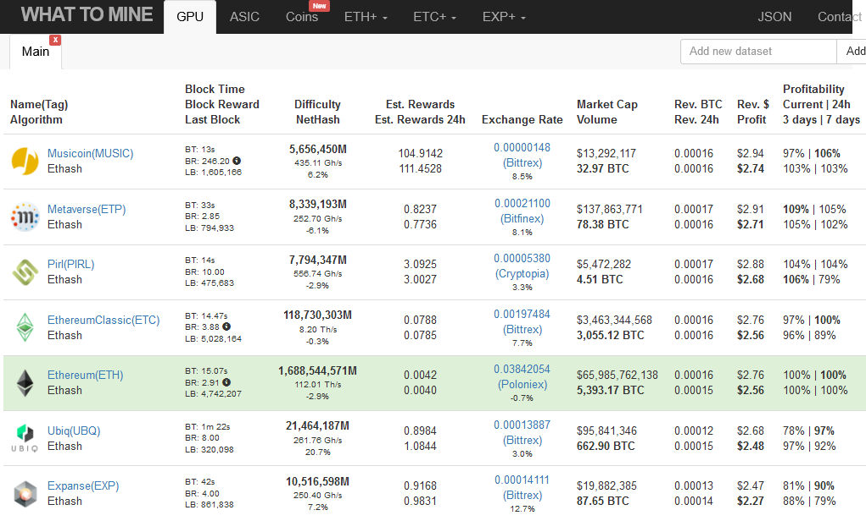

## Experiment with “Whattomine”

1. Enter your **favorite graphics card (GPU)**.
2. Change the **hash rate** and **power** **consumption** options if necessary.
3. Enter your **electricity costs**.
4. Which **cryptocurrency** you would **mine** and why?

# What to Submit?

Create a **zip file** (e.g. your-name-whattomine-exercise.zip) holding the **screenshots** of <https://whattomine.com/> with your adjustments and **text file** **“whattomine.txt”** with answer of question: ”Which crypto currency you would mine and why?”.

Submit your zip file as **homework** at the course Web site.